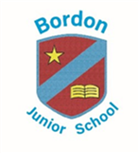
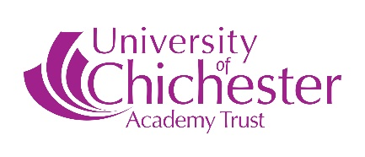

Religious Education Policy

The teaching of Religious Education encourages children to reflect on their own beliefs and values and explore their own and other people’s responses to some of the profound and puzzling questions, which form part of the spiritual and religious dimension of life.

Aims

The central aims of R.E. in the school are to help pupils to

- Grow in their spiritual development through reflection on their feelings and relationships.
- Develop skills and attitudes, which will support them in their personal, moral and social development
e.g. empathy, tolerance, open-mindedness, respect and the capacity for awe and wonder.
- Think about their beliefs and values and the values of others, both religious and non-religious.
- Develop their knowledge and understanding of Christianity and of other key religions, namely Hinduism and Judaism.

Guidelines

- In accordance with the Education Act of 1996 the teaching of Religious Education in our school follows the LEA Agreed Syllabus Visions and Insight which divides the subject into two attainment targets:
A.T.1. Exploring and Responding to Human Experience
A.T.2. Investigating Religious Traditions
- The time allocation is 45 hours per year, as recommended for K.S.2.
- Teaching is usually organised in half-termly units of work, although shorter more intensive mini topics are substituted where appropriate.
- The scheme of work follows a yearly programme in both Upper and Lower Schools. Coverage acknowledges the fact that religious traditions in the U.K. are in the main Christian, but we aim to help children develop an understanding of the key features, beliefs and practices of other principal religions. To this end, in addition to Christianity, children in the Lower School study aspects of Hinduism and those in the Upper School aspects of Judaism.
- We recognise the importance of avoiding stereotypes and placing faiths in their world wide context by using resources (pictures, posters and videos), which show believers of particular faiths from various places and ethnic groups.

Teaching Strategies

Much of our work in R.E. is achieved through whole class teaching, though group and independent work are used where appropriate. A variety of teaching methods are used including:

- Discussion
- Careful and respectful handling of religious artifacts
- Listening to stories • Visits to places of worship • Making and tasting food.
- Visits from members of faith communities
- Role play of events and practices
- Use of creative and expressive arts such as dance, music, poetry, art.
- Using ICT, e.g. for presentation, and to access information via CD Rom and the Internet • Use of stillness and reflection
- Exploiting links with other areas of the curriculum such as literacy, history and geography
Assessment
Assessment of children’s learning is based on the attainment steps set out in the Agreed Syllabus. Teachers make use of both formative and summative assessments and use our findings to inform planning. Assessment evidence may include notes on discussions, tapes or artwork as well as written work.
Equal Opportunities
The R.E. curriculum should be equally accessible to all children regardless of gender, ability, cultural, social or religious background. However, parents have the right under the 1998 Act to withdraw their children from all or part of the R.E. curriculum and in cases where this intention is expressed in writing, alternative arrangements will be made.
This policy is reviewed every 2 years by the governing body in line with the policy review schedule.

