Year 4 Long Term Overview: 2020-2021
Persuade Inform Entertain
Persuasion | Stories from other cultures | Non-chronological report | Guide
Text: Zoo  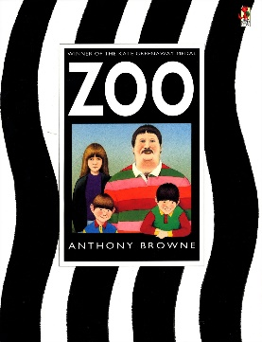  Outcome: persuasion (P)  Audience: local paper | Text: Africa is Not a Country (and others)  Outcome: Short story (E) | Text: The Wolves in the Walls  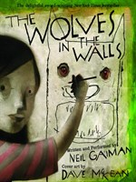  Outcome: report (I) | Text: A Guide to Ancient Rome  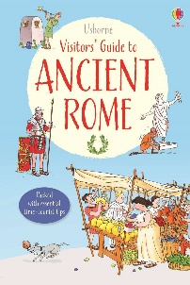  Outcome: guide (IE)  Audience: local travel agents
Imaginative Stories | Chronological Reports | Fantasy Fiction | Information Text
Text: The Hole  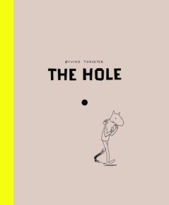  Outcome: Short story (E) | Text: Escape to Pompeii (and others)  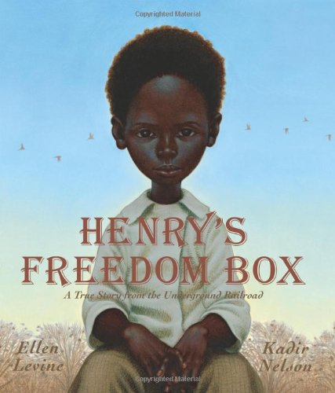  Outcome: letters (IE), newspaper reports (I) | Text: The Butterfly Lion  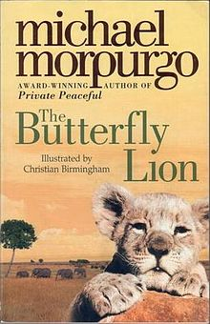  Outcome: letter (IE), short story (E) | Text: The Clue’s in the Poo  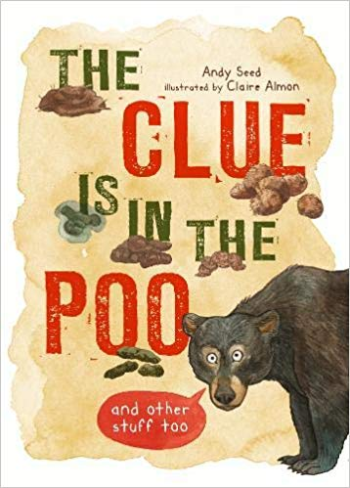  Outcome: information text  Audience: local GP surgery
Letters | Narrative | Non-chronological reports | Myths and Legends
Text: Dear Father Christmas  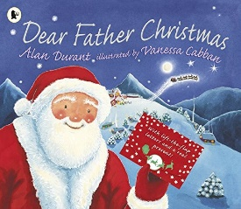  Outcome: letters (P)  Audience: Father Christmas  (unit taken from year 3/4 autumn a) | Text: How to Train Your Dragon  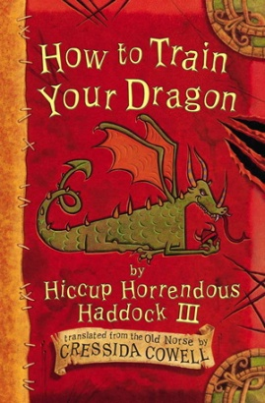Outcome: short story (E)  Audience: year 3 | Text: Harry Potter  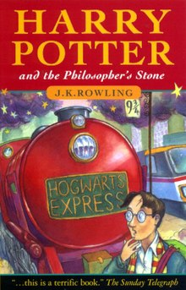  Outcome: school reports, school prospectus (PI)  Audience: prospective pupils of Hogwarts  (unit taken from year ¾, spring A) | Text: Can you Catch a Mermaid? (and others)  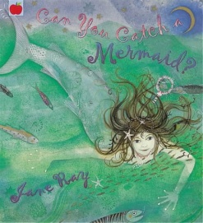  Outcome: Myth (E)

