PD –
We are all different

How can people be similar or different to each other?
Research ways in which different cultures and families can be different to each other.
Science –
Environmental change affects different habitats and living things differently

Environments can change. Sometimes they change naturally and sometimes humans change them.
Create a mind map about environmental changes answering these questions:
- Environment – What does this word mean?
- What are the different environments we find on Earth? (i.e. desert)
- What changes happen to the environments naturally?
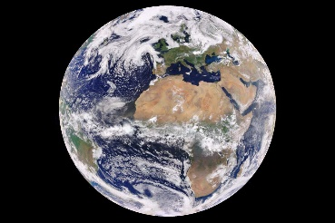
- What changes caused by humans happen to the environments?
- Are all environmental changes damaging to the environment?
Some useful links that might help:
https://www.bbc.co.uk/bitesize/topics/zp22pv4/articles/z2md82p
https://www.oddizzi.com/teachers/explore-the-world/global-knowledge/environmental-change/how-is-it-changing/
DT –
Indestructible defences
- What is an indestructible defence?
- Find pictures of some examples.
- Create a model of an indestructible defence found on the coast
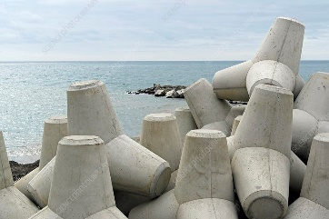
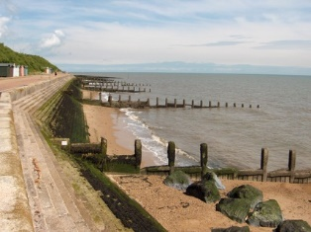
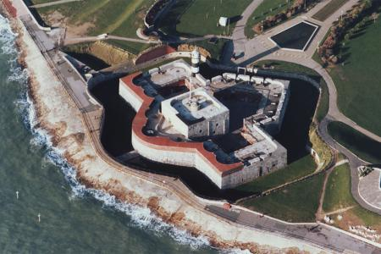
Computing –
Coding
- Continue your investigation using turtle academy.
- Work on coloured lines and building the repeated shapes
- Then look at the labelling – information below.
https://turtleacademy.com/
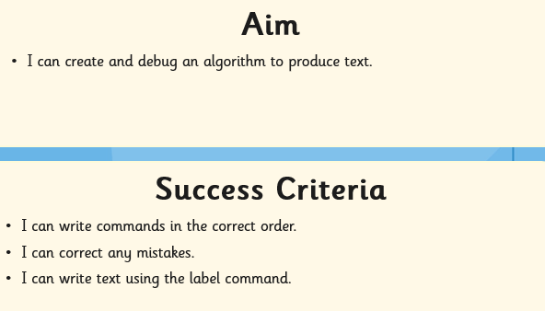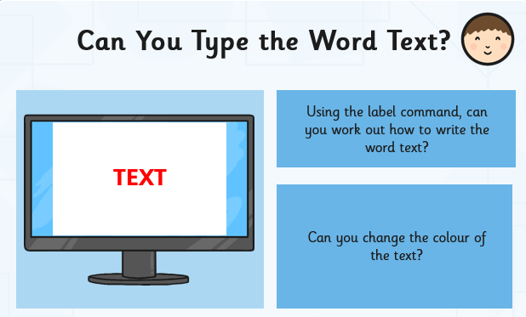
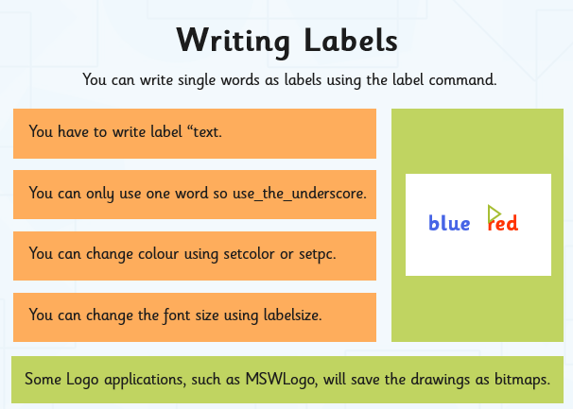
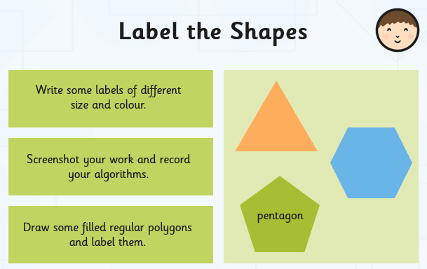
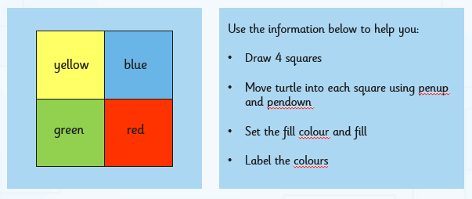
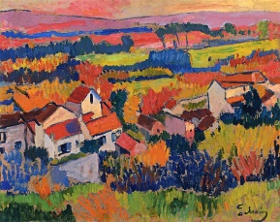
Art-
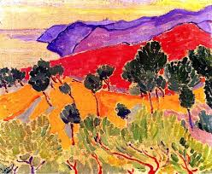
Landscape painting
- Research landscape paintings by Derain and Braque
- Paint your own landscape based on their techniques
- Use vibrant colours and block brush strokes
If you haven’t got paints, try brightly coloured felt tips or pencil or you could even try crayons and chalks.
Other ideas you could try are making you’re a landscape collage using fabric, magazines or anything from around the house – old cereal boxes, pasta wrappings etc.
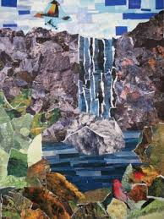
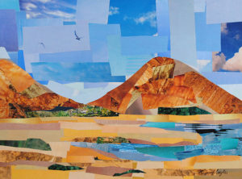

Get inspired – watch the link about the Australian artist Ken Done.
https://www.bbc.co.uk/bitesize/clips/zwfgkqt

