Year 6 Long Term Overview: 2019-2020
Persuade Inform Entertain
Recount | Story Openers and Letters | Explanation Texts | Biography
Text:  Extreme UFOs and Aliens  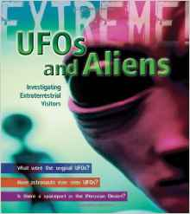  Outcome: diary (IE), report (I)  Audience: parents (UFO exhibition) | Text: Harry Potter  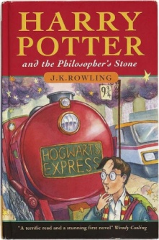  Outcome: short story (E)  Audience: year 5 | Text: Harry Potter  Outcome: explanation (I)  Audience: Twitter viewers | Text: Boy: Tales of Childhood  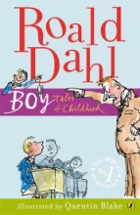  Outcome: Biography (IE)  Audience: Mill Chase school library
Poetry | Descriptive Writing | Narratives | Non-fiction
Text: The Spider and the Fly  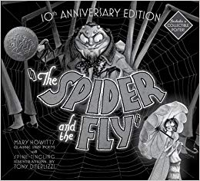  Outcome: narrative poem (E)  Audience: year 4 | Text: Harry Potter  Outcome: description (E)  Audience: primary children (accompaniment in library) | Text: Harry Potter  Outcome: narrative (E)  Audience: school website | Text: The Wonder Garden  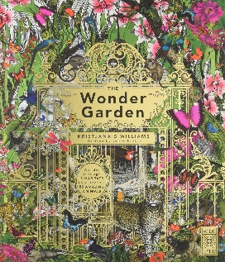  Outcome: non-fiction in the style of the text  Audience: Readers of the Wonder Garden
Historical Stories | Instructions | Journalistic Writing
Text: War Horse  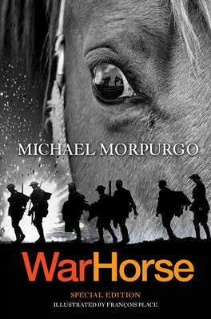  Outcome: letter (IE) , description (E)  Audience: secondary children (Mill Chase Library) | Text: Harry Potter  Outcome: instructions (I)  Audience: wizards and witches (Harry Potter manual) | Text: Tuesday  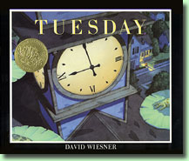  Outcome: police report (PI), newspaper report (IE)  Audience: public (local press)

