Year 5 Long Term Overview: 2020-2021
Persuade Inform Entertain
Instructions and Explanation | Recount | Persuasion | Classic Fiction – Goth Girl
Hobbies  Outcome: instructions (I), explanation (I)  Audience: year 4 children | Text:  Goodnight Mr Tom  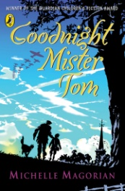  Outcome: diary (IE)  Audience: peers | Text: Where the Forest Meets the Sea  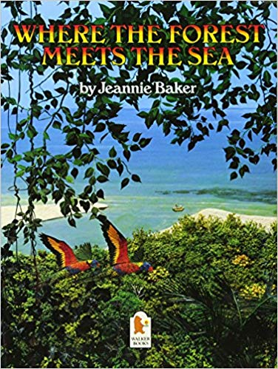  Outcome: letter (P), magazine article  Audience: school website | Text: Goth Girl  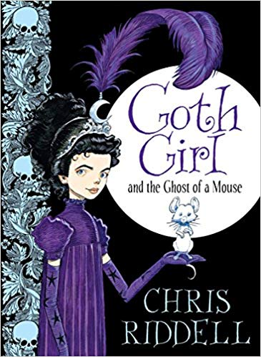  Outcome: Story (E)
Classic Fiction | Faraway Fiction | Argument and Debate | Non-Chronological Reports
Text: Just So Stories  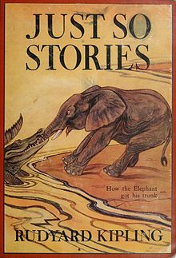  Outcome: story I | Text: Cloud Tea Monkeys and Mysterious Traveller  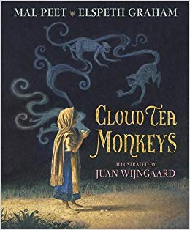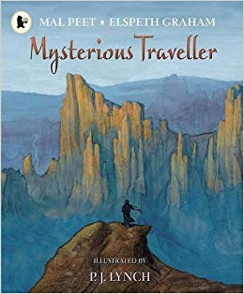  Outcome: narrative | CCTV cameras  Outcome: argument text (PI)  Audience: publish book in library (junior school chn) | Text: Monsterology  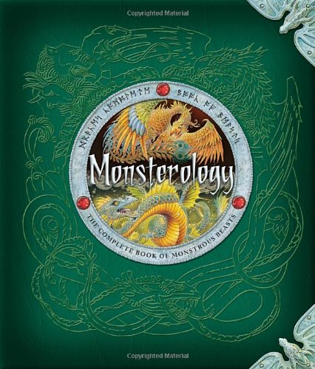  Outcome: report (IE)  Audience: publish in library
Poetry | Journalistic Writing
Text: The Debate of Tea and Coffee  Outcome: poem (E) | Text: The Emperor’s New Clothes  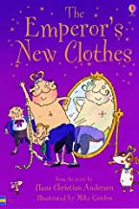  Outcome: report (I)

