Year 3 Long Term Overview: 2020-2021
Persuade Inform Entertain
Explanation | Stories about Imaginary Worlds | Recount | ???
Non-fiction: instructions and explanations  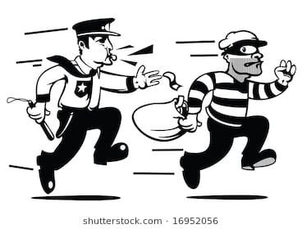  Outcome: explanation (E)  Audience: Peers | Text: Fantastic Mr Fox  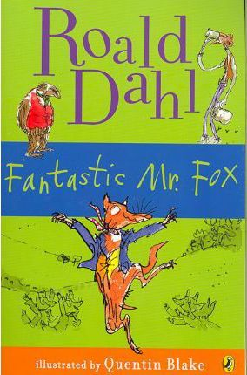  Outcome: story (E)  Audience: Parents/carers | Text:  The Day I Swapped My Dad for Two Goldfish  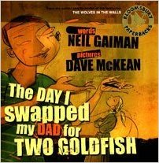  Outcome: Diary (IE)  Audience: Peers | Text: The Day the Crayons Quit  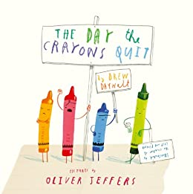
Narrative (Adventure Stories) | Persuasion | Fantasy Stories | Information Text
Text: The Hodgeheg  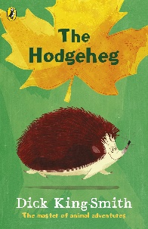  Outcome: adventure story (E)  Audience: school website | Text: How the Grinch Stole Christmas  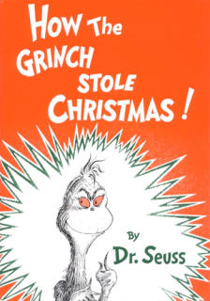  Outcome: letter  Audience: The Grinch | Text: The Guardians of Childhood  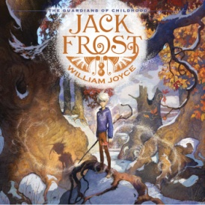  Outcome: Story (E)  Audience: Year 2s | Text: Stone Age Boy (and others)  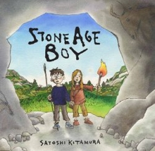  Outcome: Information Text (IE)  Audience: Butser Farm

