Hello year 4
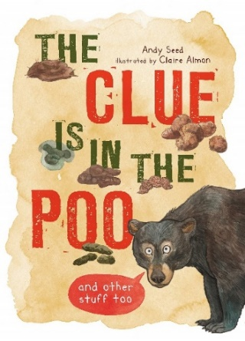

L.O. Understand the features of a text | 1) Look at the WAGOLL on the website  2) Can you locate the features of an information text in this WAGOLL?  - Subheadings  - Title  - Pictures with captions  - Technical vocabulary  - High-level vocabulary  3) Locate three grammatical devices in this text that you have learned about in year 4.  You might find things like:  - Fronted adverbials  - Complex sentences  - Subordinating conjunctions
L.O.  Recognise and use complex sentences | Today, we are going to be revisiting complex sentences.  - Watch the video for session 2 on the school website.  - Can you spot the complex sentences in this text?  The sun was beginning to disappear behind the nearby mountain. Philip’s heart sank as he knew he was lost. The group of climbers, who Philip had started out with, were nowhere to be seen. Philip shouted for help but it was hopeless. While there was still a little light, Philip tried to make himself a bed using leaves and twigs. The temperature, which was now close to zero degrees, could be extremely hazardous. If he couldn’t find a way to keep warm, he would be in serious danger. It was going to be a long night.  - Turn these sentences into complex sentences:  - My little sister is so irritating.  - The dolphin jumped up from the water.  - Tim Peake is a famous British astronaut.  - The house on the hill remained unsold.  The ‘I SAW A WABUB’ sheet is also attached to this document to help you out.
L.O. Identify and use apostrophe correctly | 1) Watch the session 3 video on the website  2) Complete the tasks below  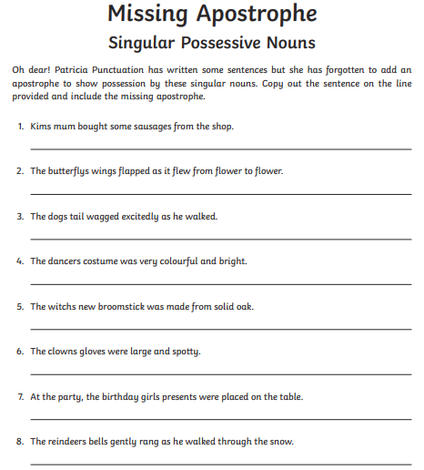  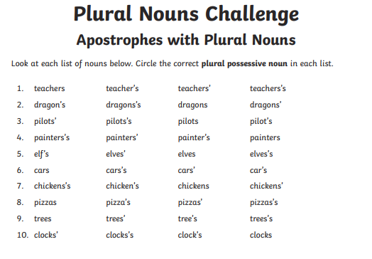
Grammar activity | 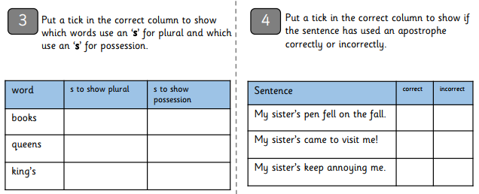  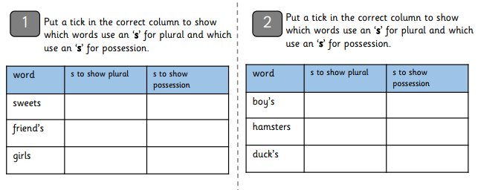
Spelling | 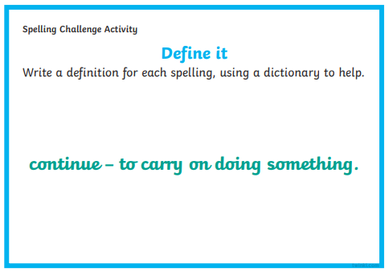  material  quarter  surprise  therefore  although  purpose  increase  eighth  disappear  experience  consider

