|  |  |  |  |
| --- | --- | --- | --- |
| **January 2020** | 6th | Whole school | INSET |
|  | 7th | Whole school | Start of term |
|  | 13th | Whole school | Parent Consultations 3.30-5.30 pm |
|  | 14th | Whole school | Parent Consultations 3.30-7pm |
| **February** | 17-21st | Whole school | Half term |
|  | 25th | Whole school | Parents invited in to eat with their child and try a hot lunch-details to follow |
|  | 26th | Year 4 | British Museum trip |
|  | 27th | Year 4 | British Museum trip |

Issue: 4 December 2019

”

­

Dear Parents and Carers,

Unbelievably we’re at the end of the Autumn Term already - a third of the way through the school year! The last few weeks have been incredibly busy in the run up to Christmas. There have been a variety of activities taking place right across the school, including most recently a group of children singing at the Bordon Schools’ Christmas concert, Christmas lunch, two performances of the Year 3 and 4 play, children from Years 5 and 6 singing at a nursing home and a carol service attended by 250 children and families. We’ve been extremely proud of the way the children have responded to opportunities to act, sing and read in front of large audiences and we hope that they have enjoyed these events. A huge thank you to all the different members of staff for their hard work - none of the events would be possible without their time, care and dedication. Please can we take this opportunity to wish everyone a very happy Christmas and New Year, and we look forward to seeing all children return to school on Tuesday 7th January 2020.

Yesterday Miss Robinson and I took 15 Year 5 and 6 children to Tilford Care Home to sing to the elderly residents. It was a fantastic community event and the children really enjoyed spreading the Christmas Cheer. Whilst we were at the care home, we gave out Christmas Cards and sang carols to 15 of the permanent residents. We were greeted with smiles and dancing and were given hot chocolate and home-made cookies to finish.

All the children who sang, Miss Robinson and myself would like to send our Christmas wishes to the wonderful residents and staff. year.  Mrs Edwards

SASA SPECIAL SECRET REPORT

After Christmas, SASA (School Academy Space Agency) will be returning to Bordon Junior School. With a group of 15 Year 4s, we will be looking at various different projectiles and determining how we can make them the most efficient they can be. This incorporates the STEM learning we are looking at through our Science units and adds to the broad and balanced curriculum we provide. We will spend each Friday afternoon creating and testing different rockets. We will be taking the group on a Scientific trip. However, this will remain TOP SECRET for now.

Sports Fixture

Our children have shown fantastic commitment to sport over the past few weeks. Years 5 and 6 participated in a Hockey Tournament in the pouring rain, all years have participated in our 'Intra-class' Tag Rugby tournament during lunchtime and a group of children got involved in an 'inclusive sports festival'.  We are very proud of the sportsmanship, teamwork and resilience they have shown in sports competitions and in their PE lessons this term.

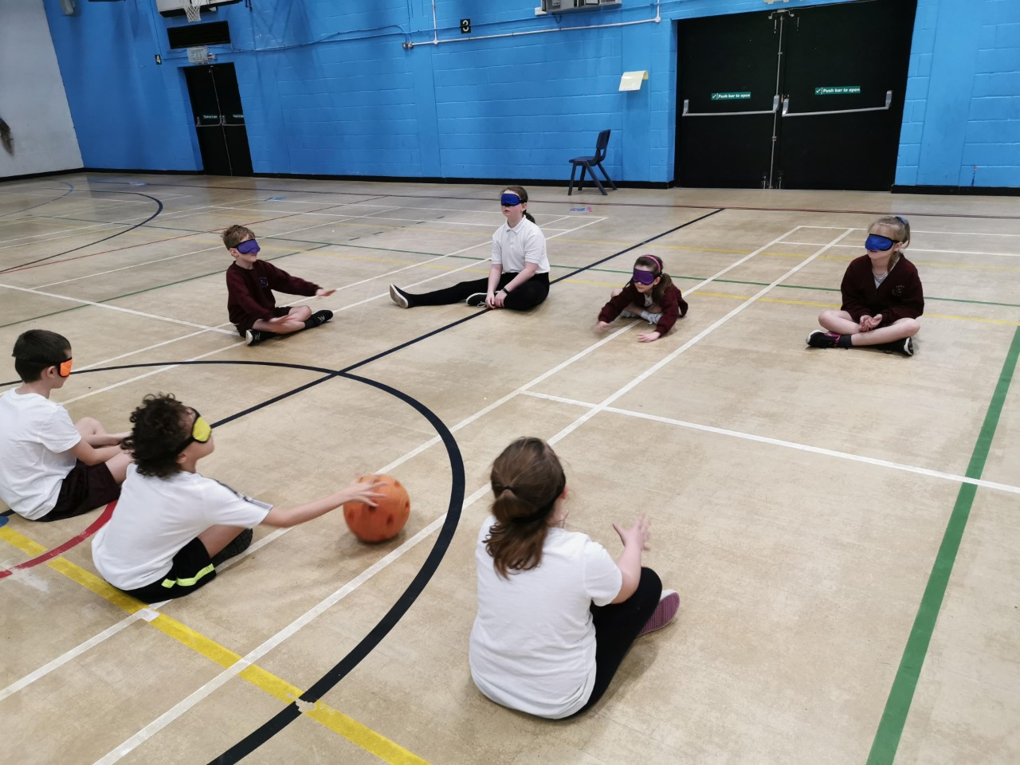



Reminder

How are you getting on with the reading the books on the lists that were handed out on Parents’’ Evening? The Christmas holidays could be a good time for you to enjoy some reading together ☺

|  |
| --- |
| C:\Users\wrend\AppData\Local\Microsoft\Windows\INetCache\Content.Word\DSC09086.jpg  Year 5 Art Day  Year 5 were very lucky to be given the opportunity to have an ‘Art Day’ focussed on printing. The children created full size friezes of the journey of a river from source to mouth, using different printing techniques to create textures.  Part of the project was to design their own t-shirt about environmental awareness which the children then made using their printing skills and fabric paints.  “It was a really good day and a lot of fun. I’m glad we spent a whole day working in groups and on our own because we learnt more than we would have in a single lesson. I’m really proud of my t-shirt.” Izabella.  Ollie said, “It was an awesome day and we learnt new art skills.” |

”